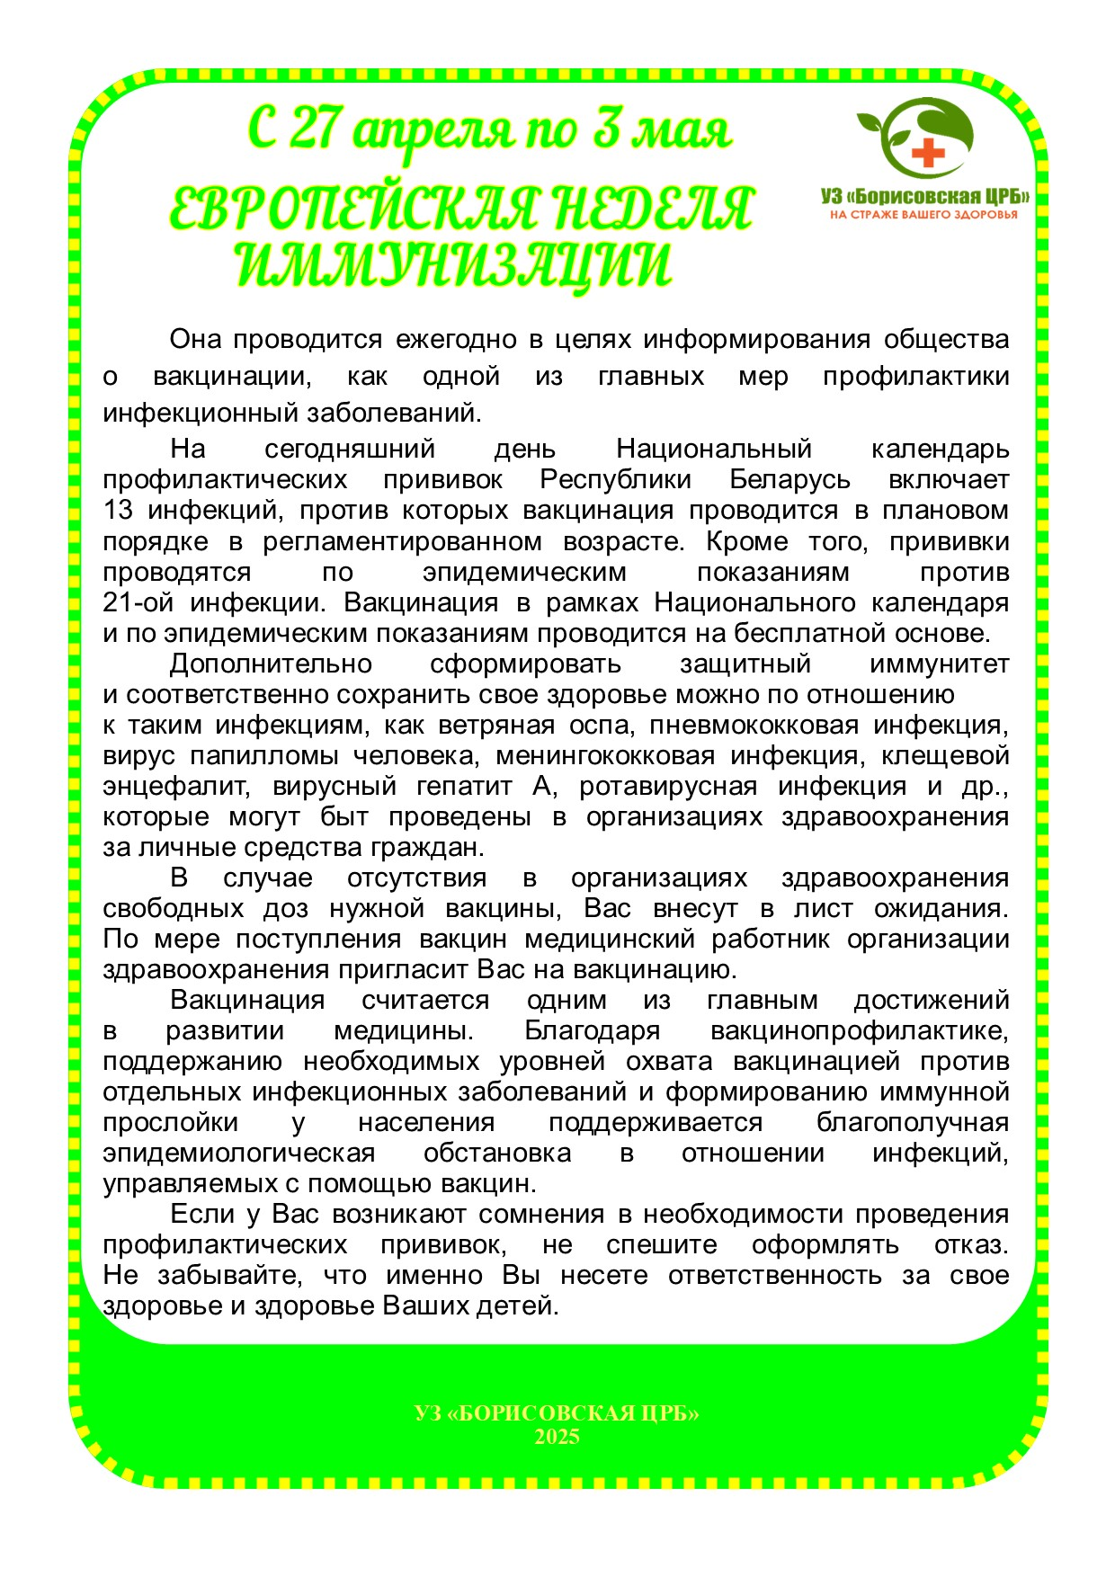

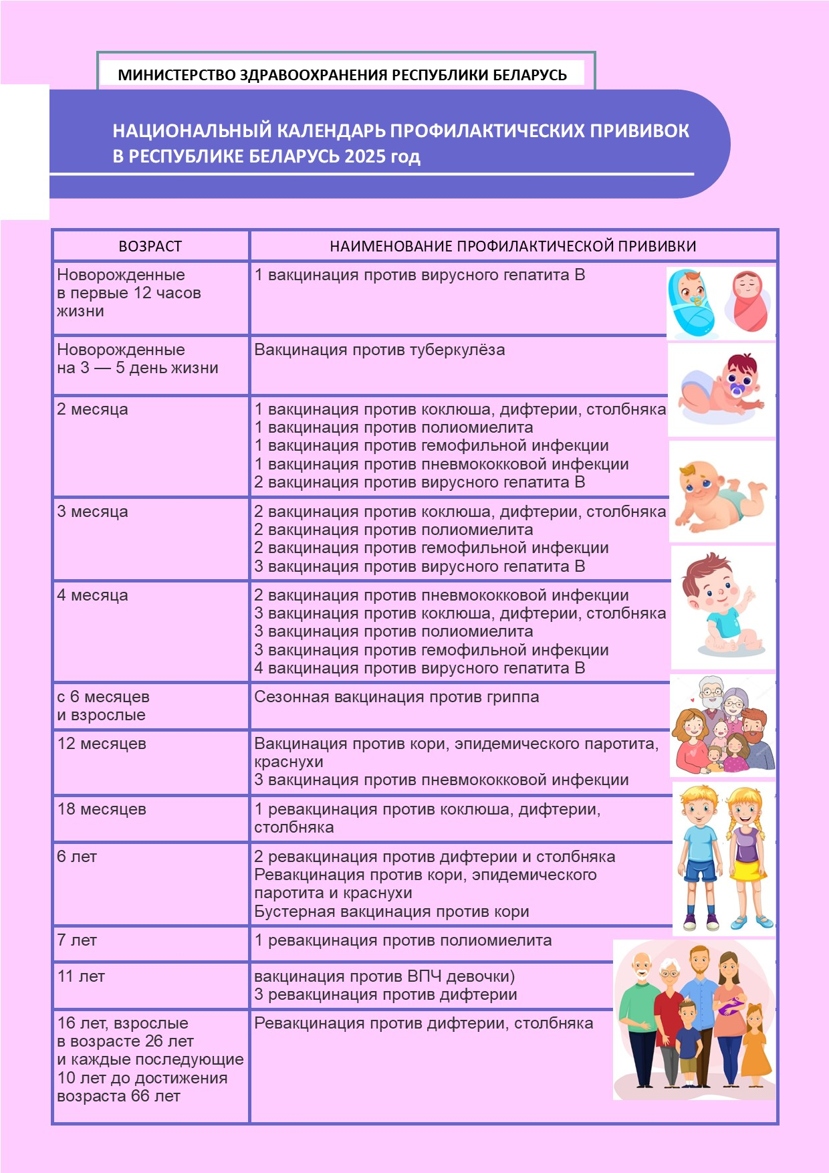

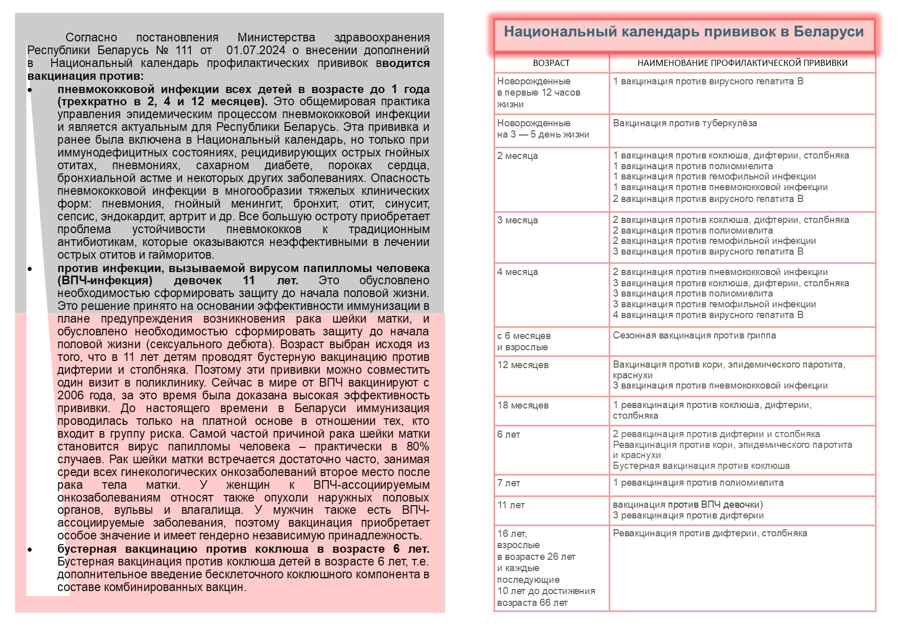

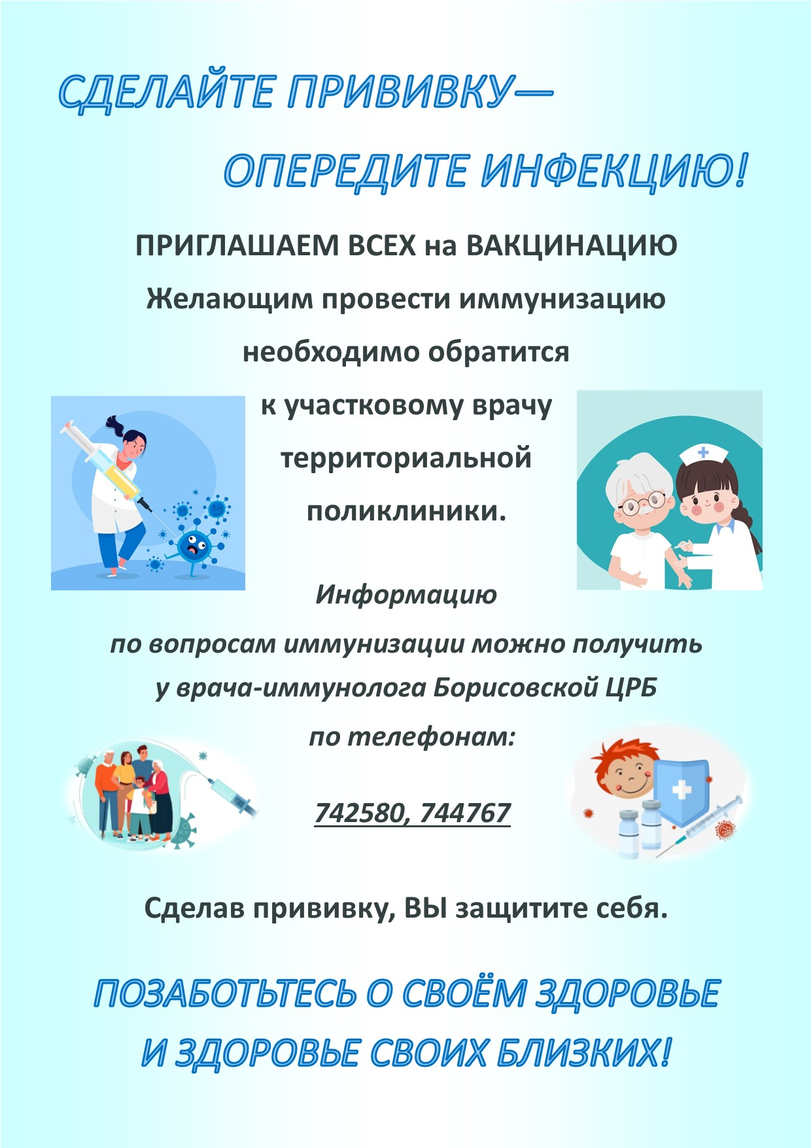

Полезные ссылки:

<https://who.canto.global/v/REM6RG8BDI/album/QD1M8?display=fitView&viewIndex=0&gSortingForward=false&gOrderProp=uploadDate&referenceTo=&from=fitView>

<http://cgeud.by/2025/04/26/%D0%B5%D0%B2%D1%80%D0%BE%D0%BF%D0%B5%D0%B9%D1%81%D0%BA%D0%B0%D1%8F-%D0%BD%D0%B5%D0%B4%D0%B5%D0%BB%D1%8F-%D0%B8%D0%BC%D0%BC%D1%83%D0%BD%D0%B8%D0%B7%D0%B0%D1%86%D0%B8%D0%B8-2025/>